Author registration and manuscript submission

- Author registration procedure in the SREES - Open Journal System at website
https://srees.sggw.edu.pl/
- button REGISTER - upper right corner of the window

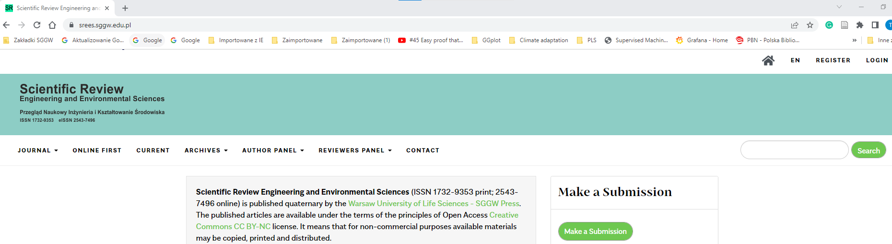

- fill up the registration form
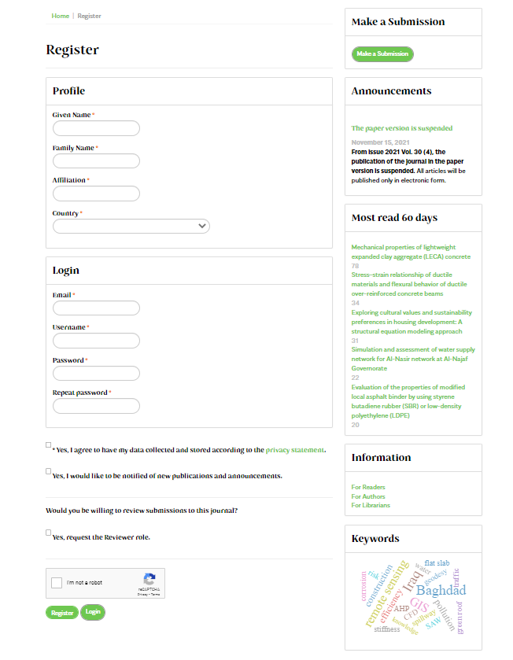

- Submission of the manuscript via the OJS system,

- button LOGIN – upper right corner of the window

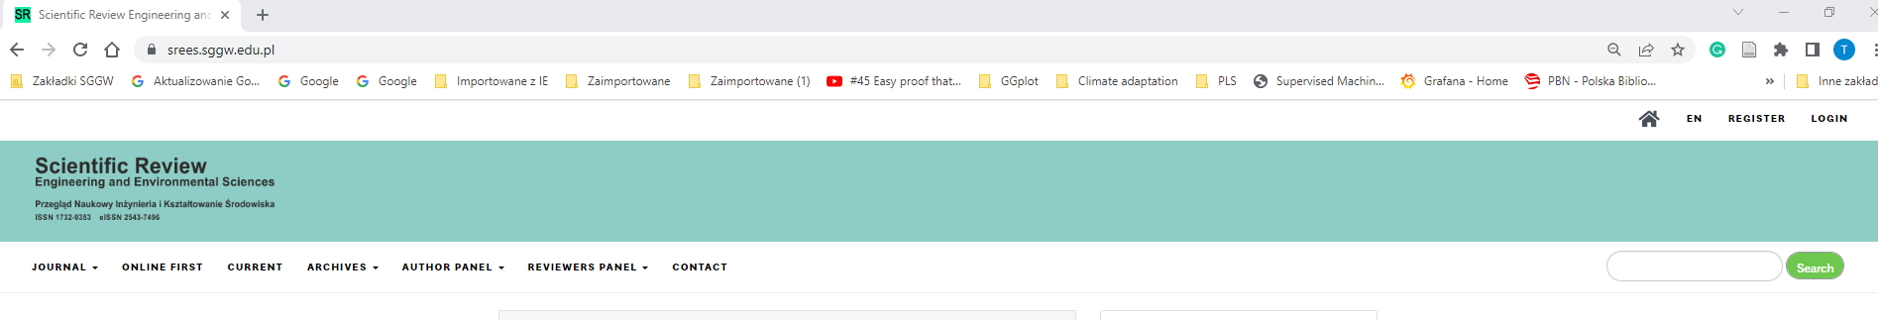
- button LOGIN – upper right corner of the window –
- then please fill up Username and Password and pus green button Login
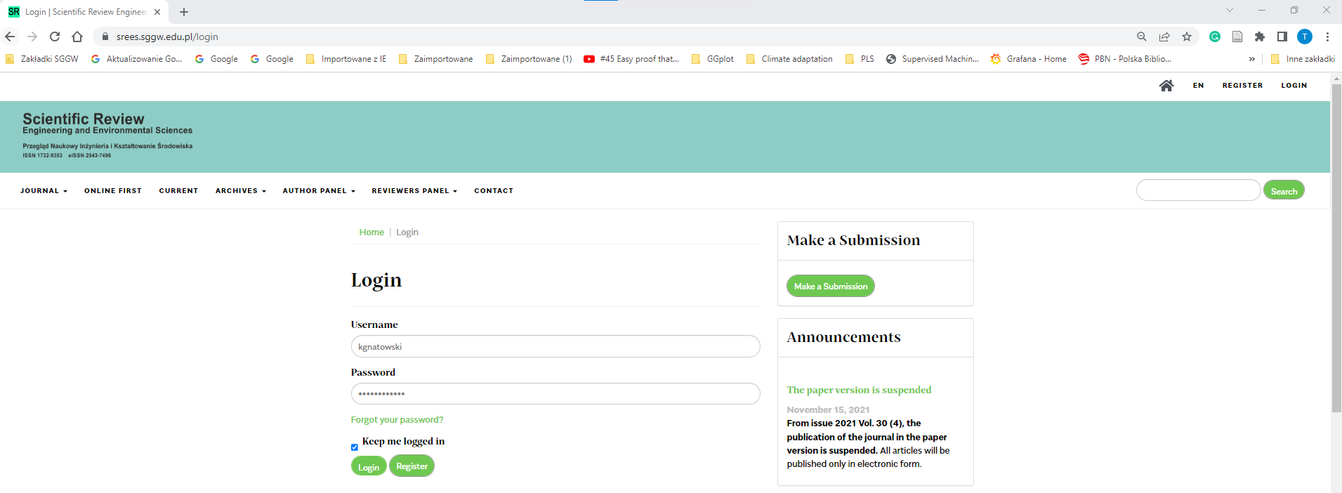

- make New Submission

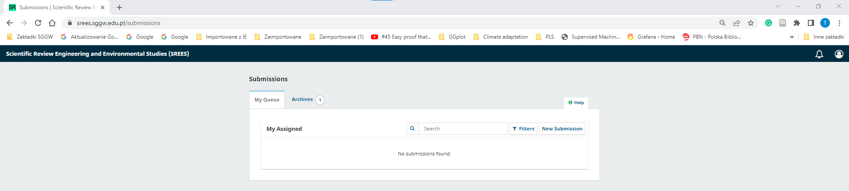

- Fill up all of the fife steps of submission
- In first step (1. Start) please fill the window Comments for the Editor – please fill it with statement about participation in the 7TH INTERNATIONAL CONFERENCE ON INNOVATIONS AND CREATIVITY

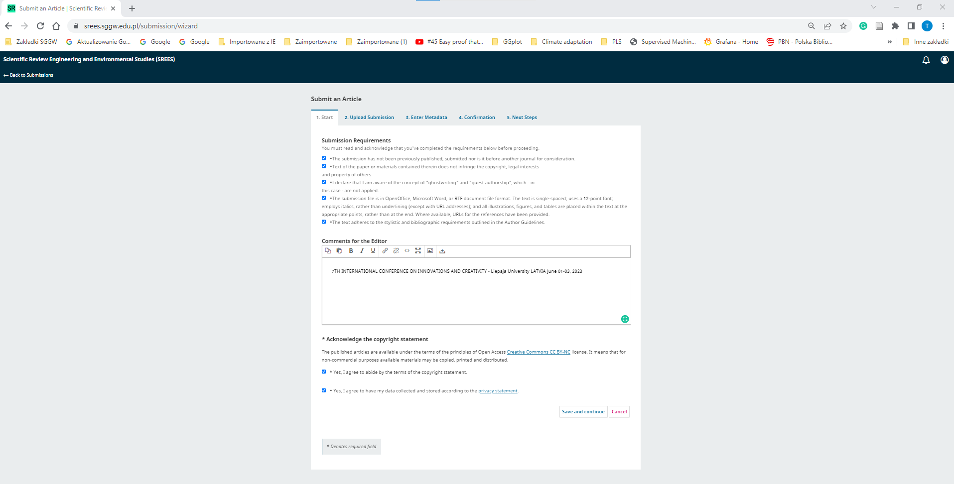

- Uploading the file with manuscript – the manuscript should be prepared according to requirements included at the SREES website (https://srees.sggw.edu.pl/about/submissions)
- Button Add File (right upper corner) and chose the manuscript file

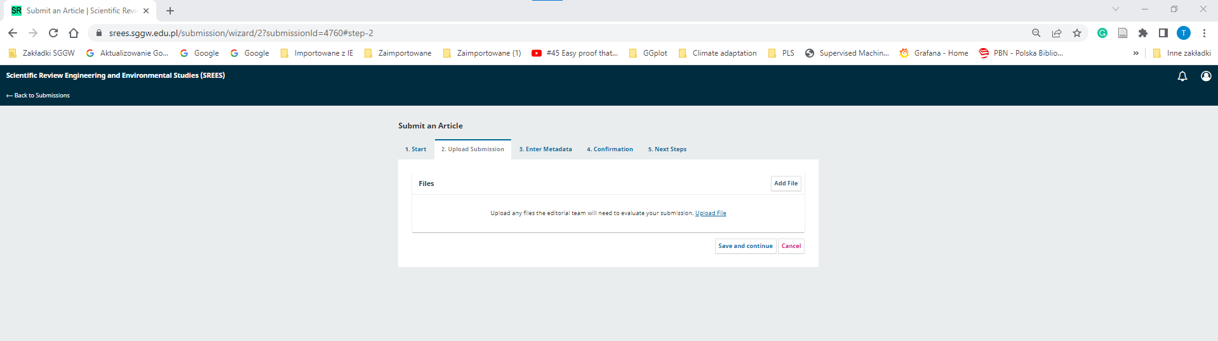

- Button Article Text – please accept and then Save and continue

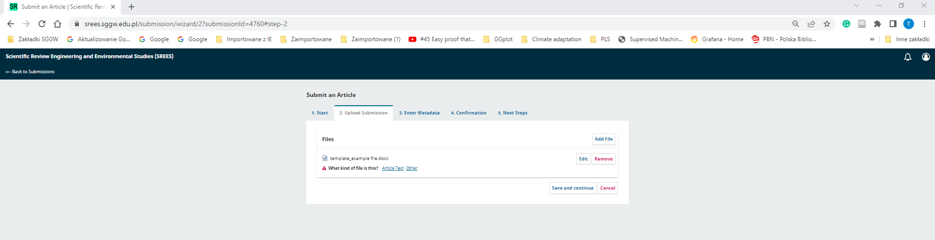

- Enter Metadata – please Add all Contributors of the manuscript (button Add Contributors)
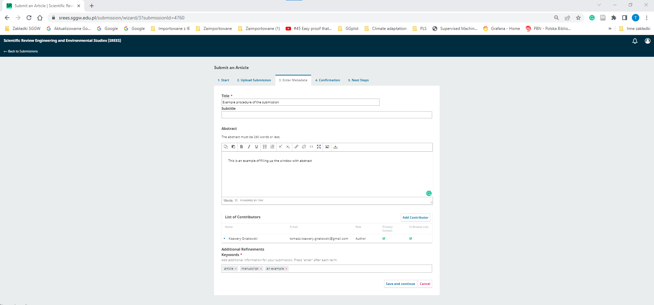
- Save and continue button

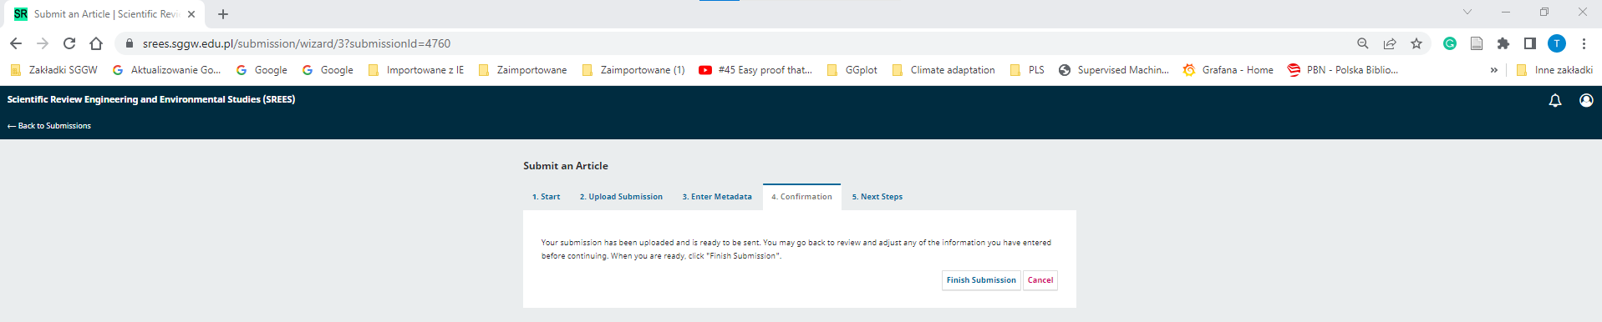

- Finish of the submission -After pushing button Finish Submission make the confirmation by pushing OK button and then the submission will be finished in few second

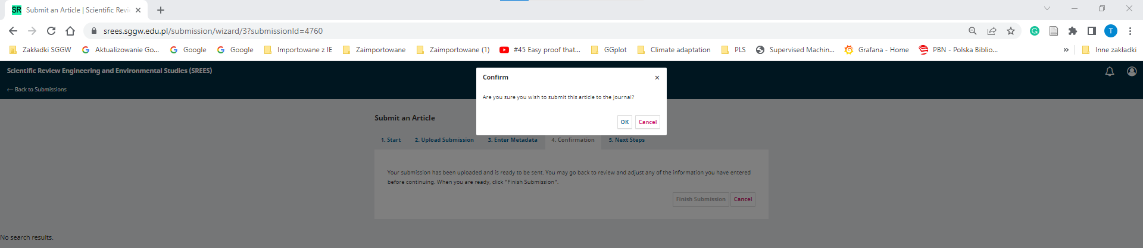

Editorial Assignments

3) The cross-ref report (similarity check),
4) The preliminary assessment of the manuscript for the SREES requirements,
5) Reviewers’ selection by the conference secretary (contact via e-mail with Editor),
6) Editor assignment
7) Sending manuscript to reviewers
8) Reviewer reports sending back to Authors
9) Author correction after revision- manuscript improvement
10) Preliminary acceptance and payment by Authors

